Agenda-To send a birthday wish to an employee o his particular date of his birthday

So first creae one data type with info

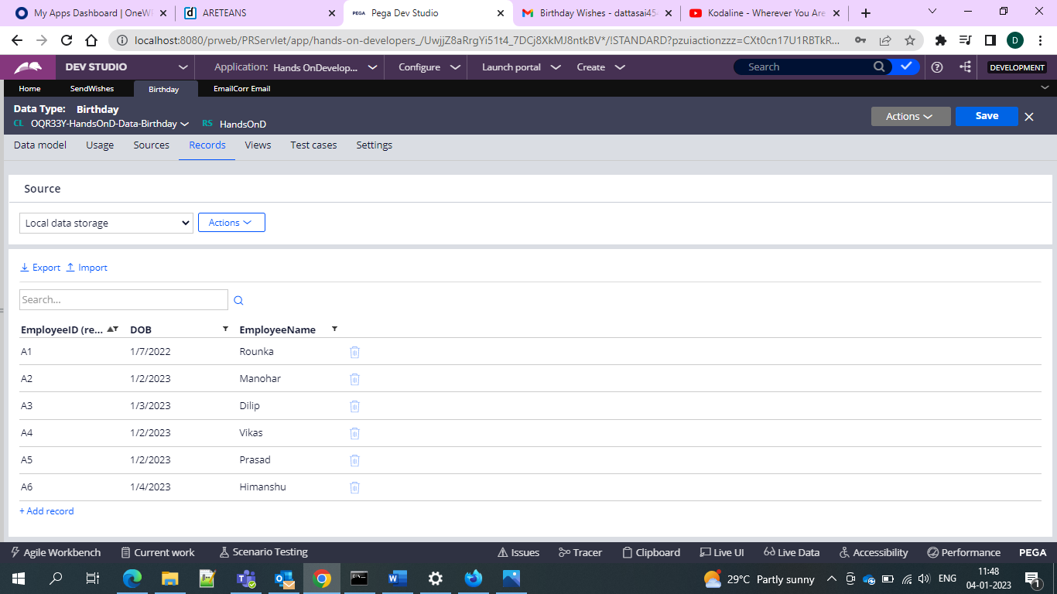

And now can create one activity to call the data page and loop the results here and check for the birthday date and send email

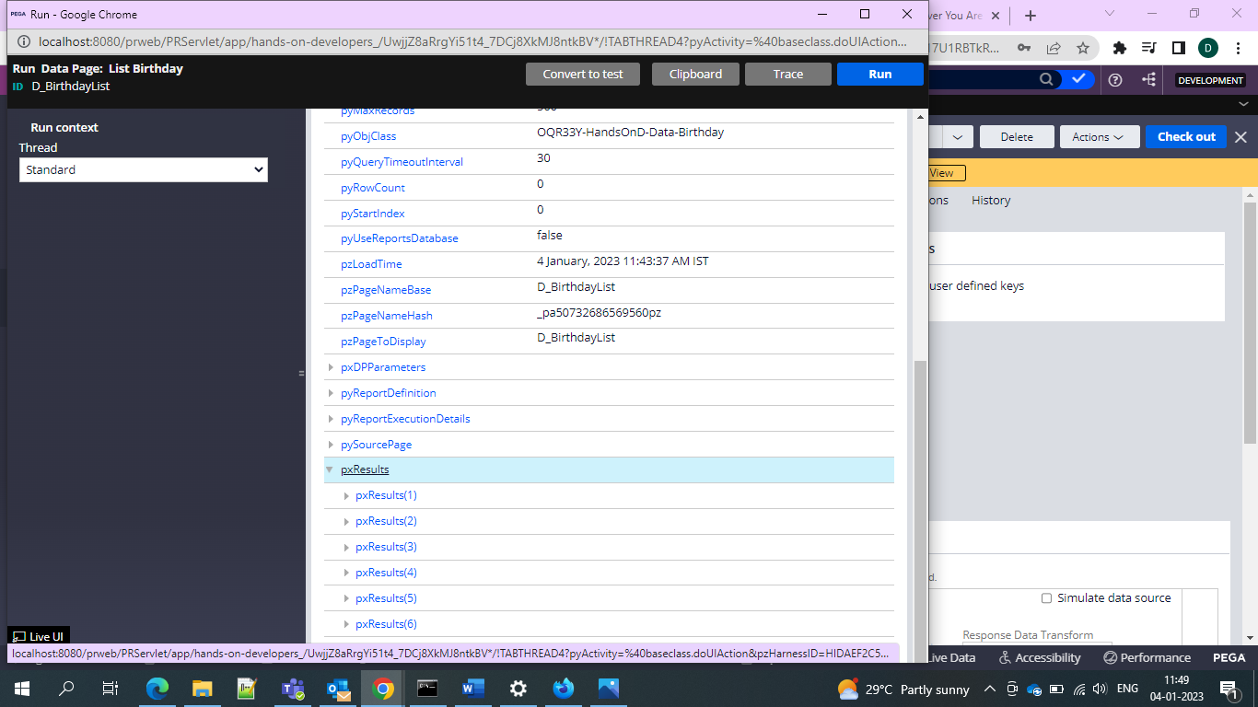

Now we can give as to flush everytime when we fetch the results and get the value

And then use the pzFlushDataPage and specify your page

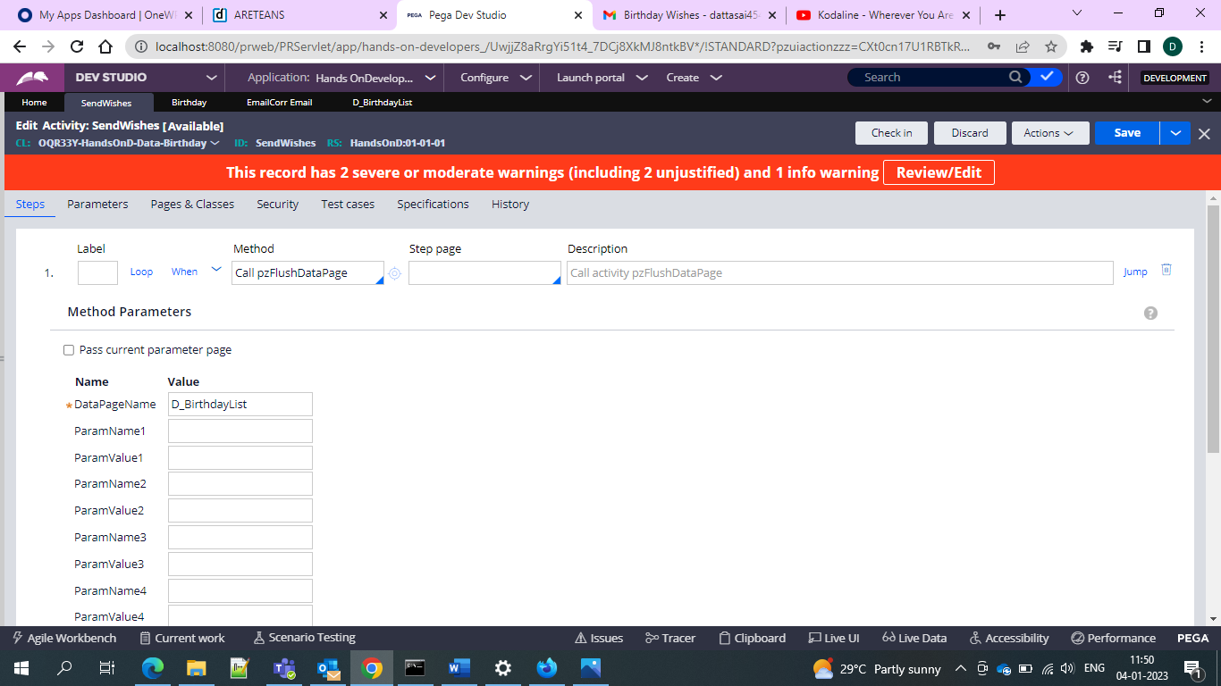

And then go for the usage and then loop the results for the class

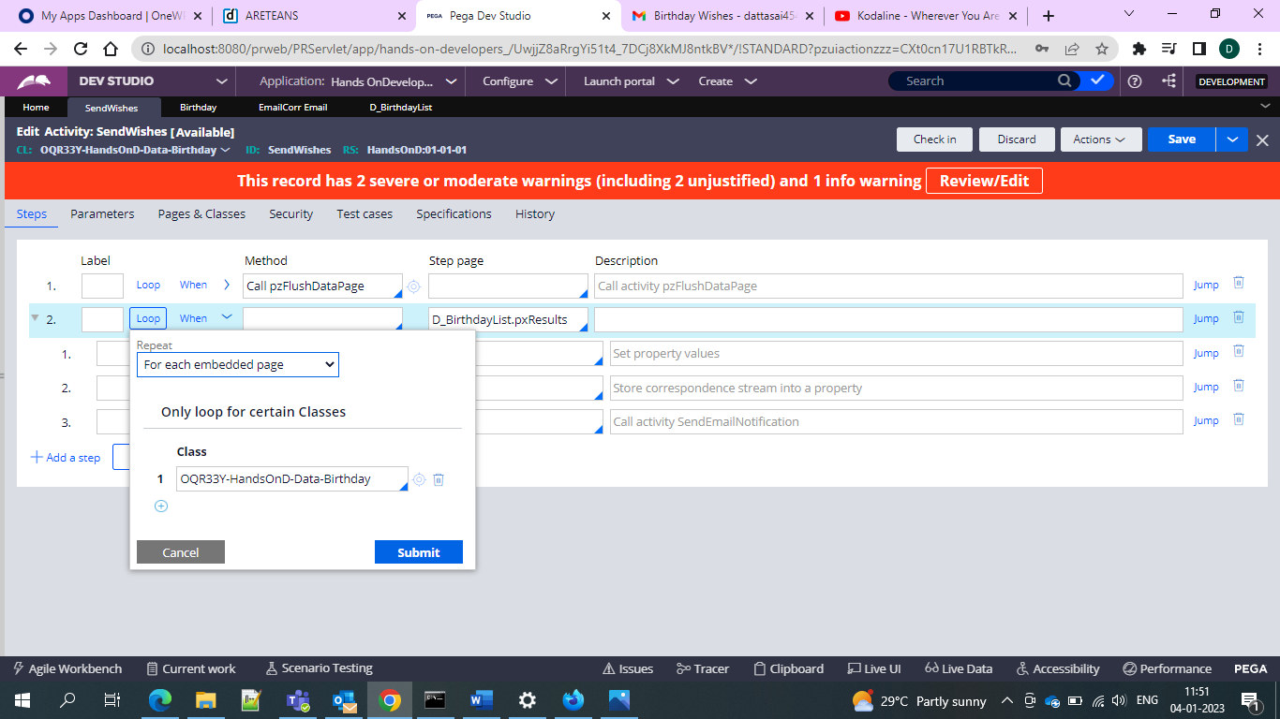

And then add the propery-set and your DOB for the property to check and then we can get the DOB and the current date of the month

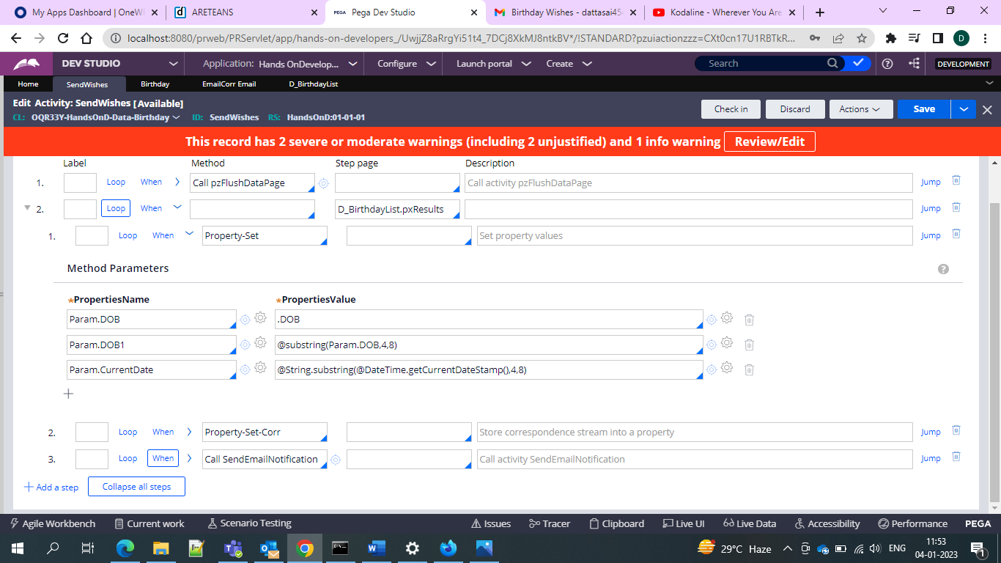

And then for the correspondence use the property-set-corr and give as below

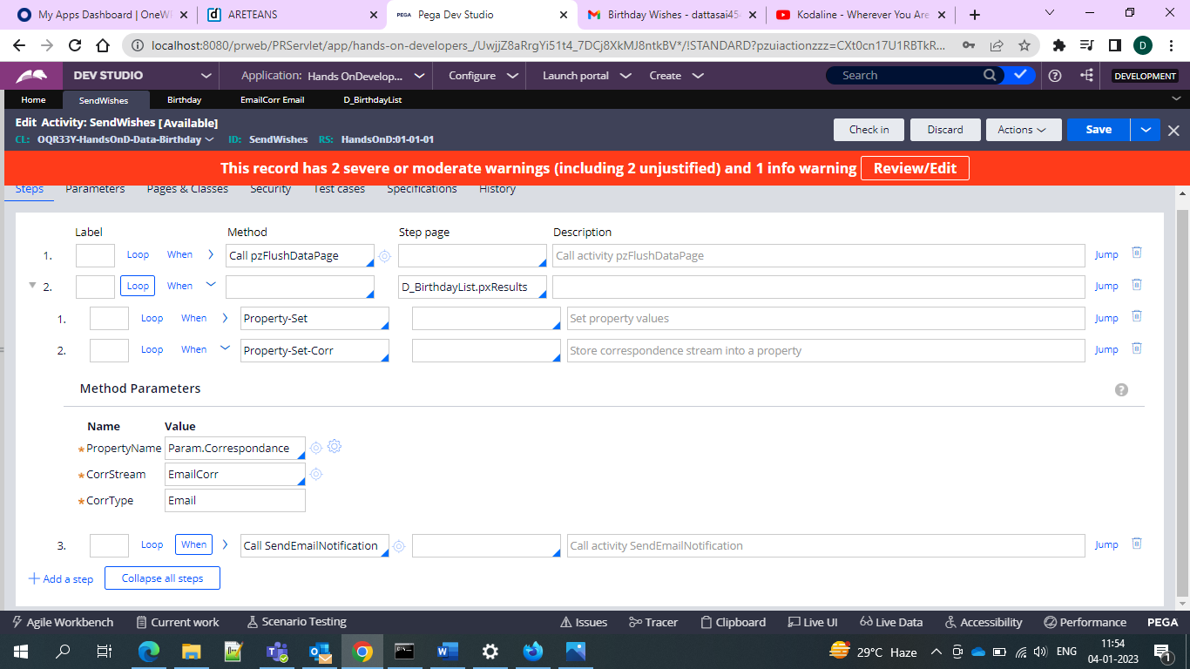

And then use the send email notification to send the emails

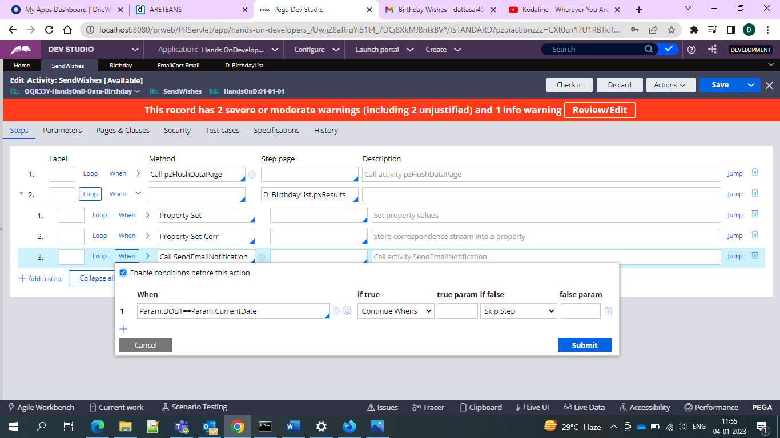

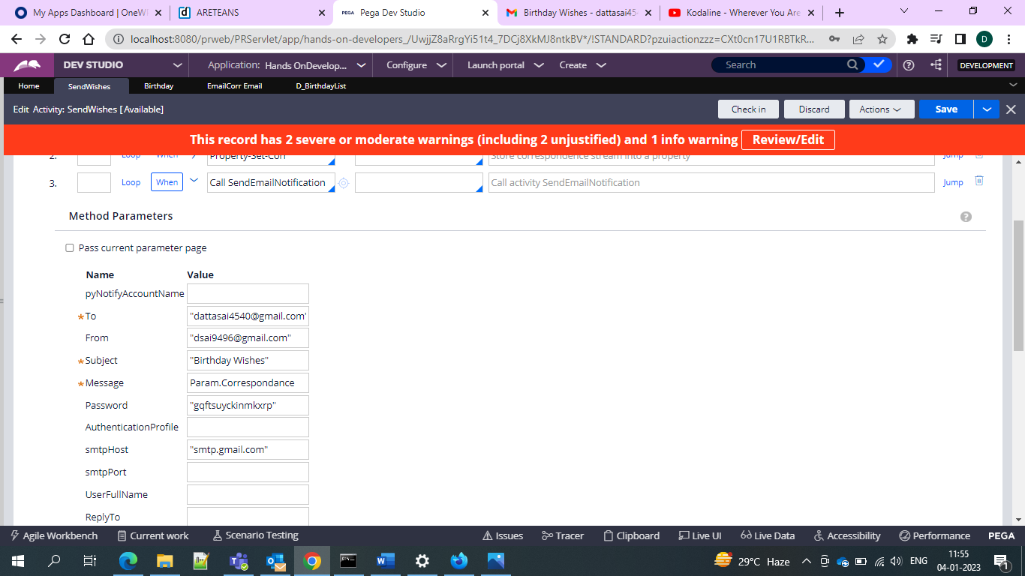

And then save the activity

And then run and check email

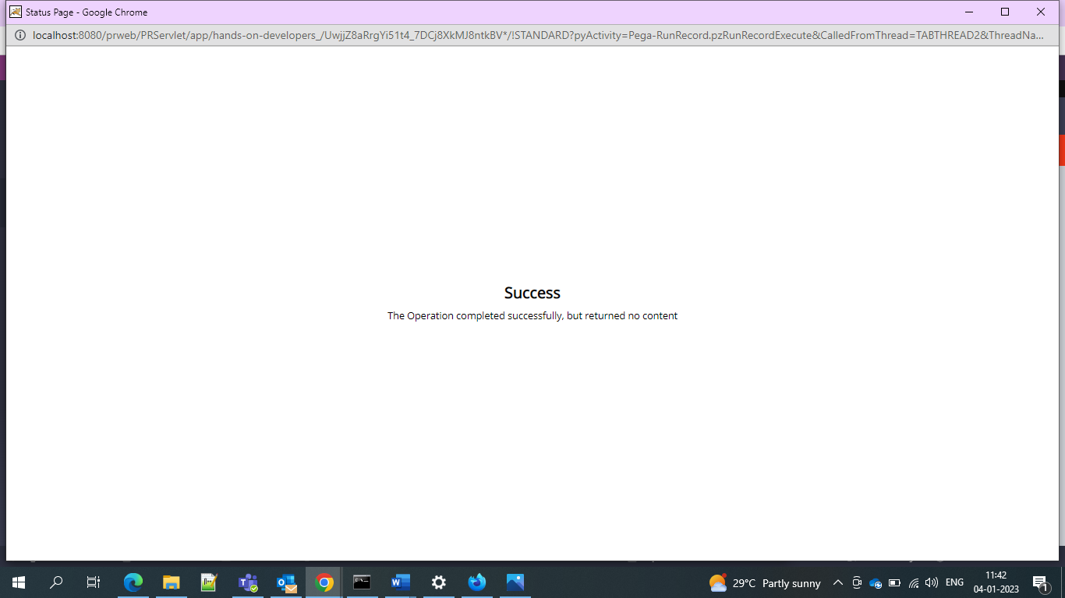

And now the email

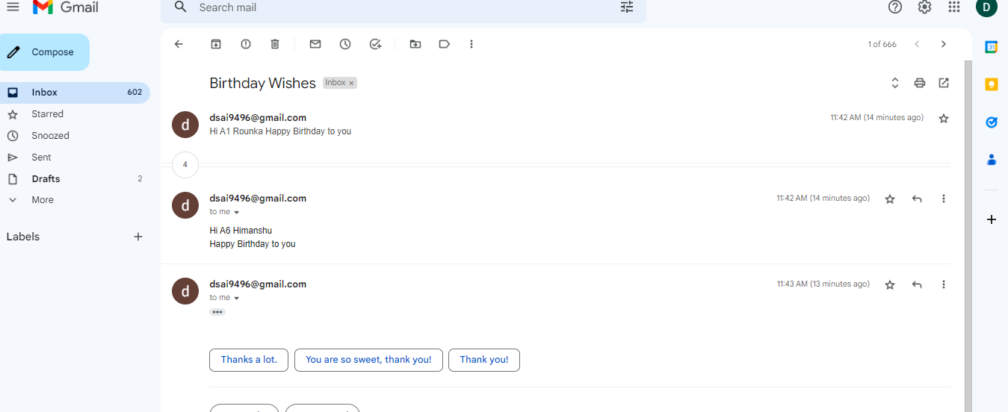

And email is sent to Himanshu since his birthday is on the 4th of January